个人简历
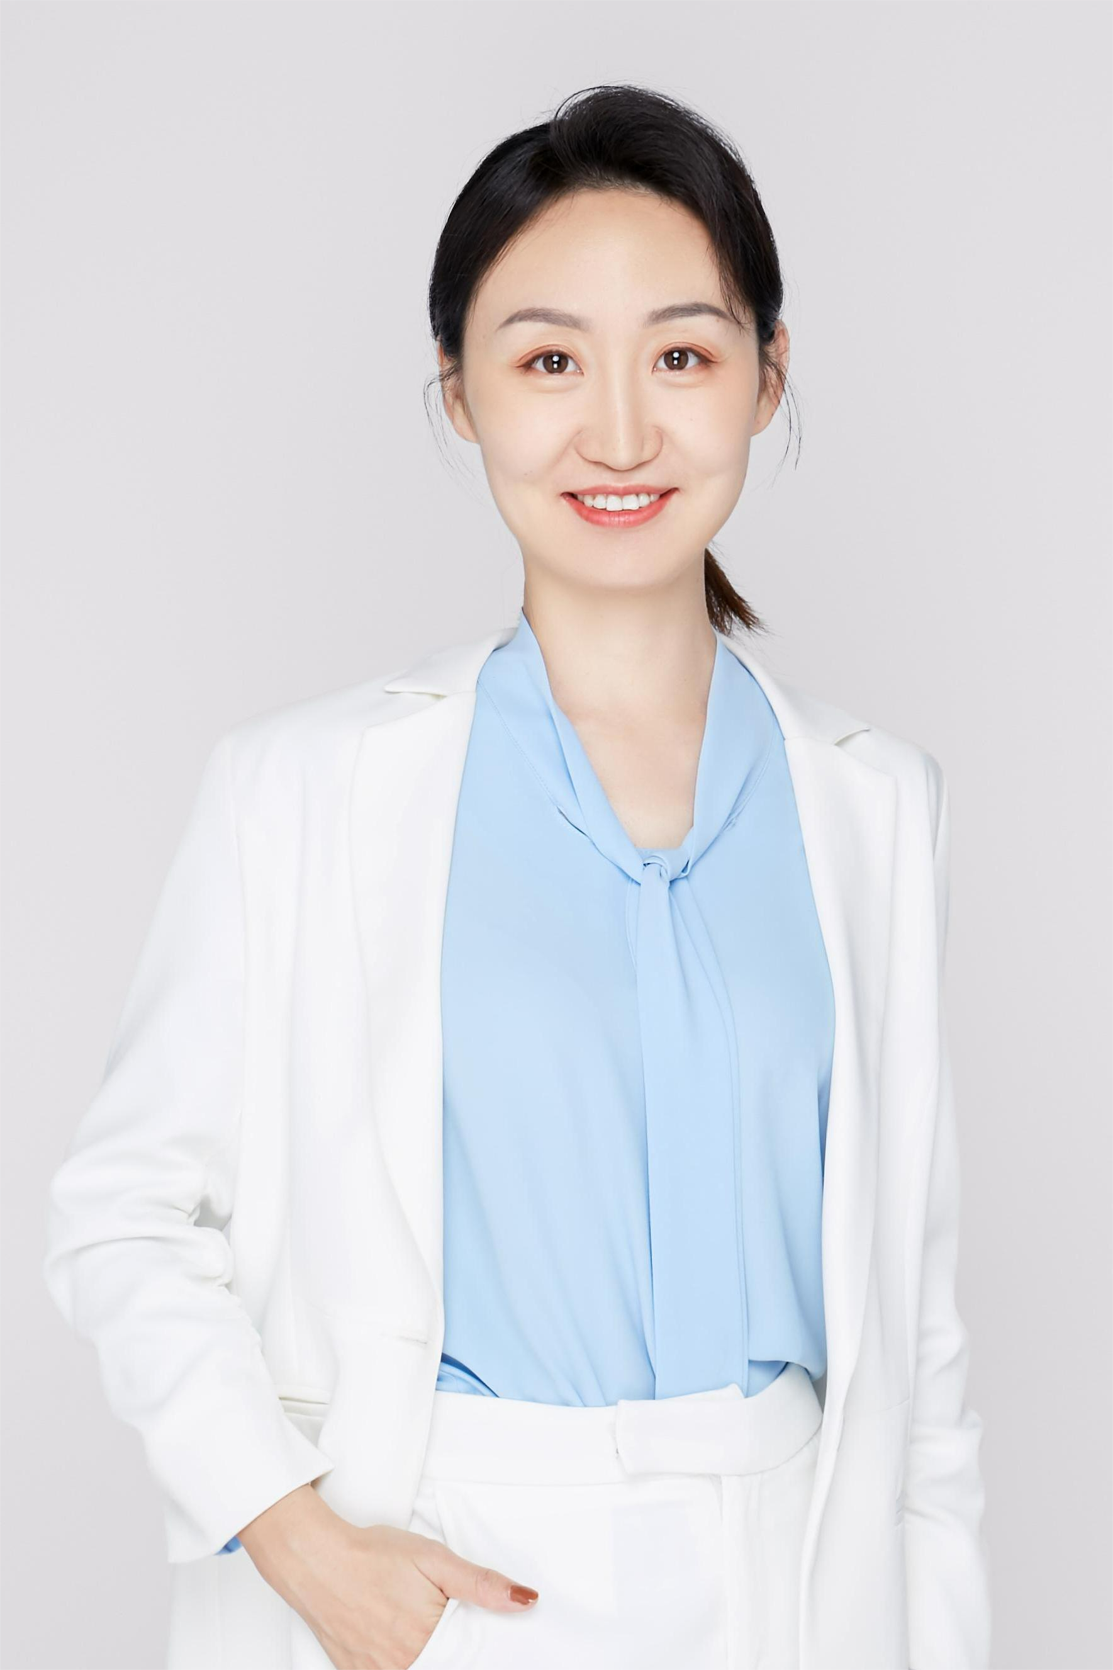
- 导师的个人情况概括
黄薇园，女，1984年生，甘肃兰州人，中共党员，硕士生导师。2014年毕业于复旦大学。2014年至今于海南省人民医院放射科工作；于2019年5月-2021年6月在美国康奈尔医学院磁共振重点实验室访学一年；并于2020年12月-2021年6月于中国科学院分子影像国家重点实验室访学半年。现为海南省人民医院放射科副主任；医学影像学教研室常委副主任；副主任医师；硕士生导师。专业方向为放射影像学，擅长中枢神经系统及头颈部影像诊断及研究工作。主持国家自然科学基金面上项目1项，主持国家自然科学基金地区项目2项，主持海南省重点科技项目2项，参与国家自然科学基金项目2项。本人以第一作者及通讯作者在本专业权威杂志发表SCI论文20篇，累及影响因子达七十余分。学术兼职包括:中华医学会放射学分会青年委员会委员；中华医学会放射学分会分子影像学组委员；中国医师协会放射学分会AI学组委员；中国医师协会放射学分会组织与会员学组委员；中国医学装备协会磁共振成像装备与技术专委会AI学组委员；海南省医学会放射学分会专委会秘书；海南省医学会放射学分会青年委员会副主任委员；海南省医师协会放射学分会专委会委员兼秘书。多次在全国性学术会议上进行讲座及学术交流活动，与全国同道分享我们的研究成果。海南省医学会与本单位联合组办了多次全省学术会议，将这些研究成果推广应用于省内其他高校及科研单位，为磁共振新技术的推广应用做出了重要贡献。
- 研究方向
科研工作主要内容是以磁共振新技术新序列为工具，以重大中枢头颈部疾病为切入点，探索磁共振功能成像新技术在临床中的开展应用。重点关注海南省高发的重大肿瘤性疾病-鼻咽癌，以临床最亟待解决的问题为切入点，将多种磁共振新技术（定量磁化率图、高角分辨率扩散成像、扩散峰度成像、体素内不相关成像及动态对比增强等）应用于鼻咽癌的分期、放化疗敏感性预测及远期预后评估等关键问题，成功创立了可以早期无创性预测鼻咽癌放疗敏感性及放射性脑损伤的影像学指标，解决了临床无创性预测乏氧状态、放疗疗效及放射性脑损伤的难题，为鼻咽癌放疗计划的“个体化”制定及后续治疗方案的选择提供帮助，从而降低残留与复发率、改善预后。在鼻咽癌的磁共振多模态研究领域达国际前沿水平，建立了以放射科、放疗科、耳鼻喉科及病理科多学科合作模式为主体的科研团队，积累了较丰富的实践经验，掌握了多项国际先进磁共振成像关键技术，取得了一些初步的研究成果。
- 发表的学术论文和专著（第1作者或通讯）
- Wenhui Huang#, Kun Wang#, Weiyuan Huang#, Zicong He, Jingming Zhang, Bin Zhang, Zhiyuan Xiong, Kelly McCabe Gillen, Wenzhe Li, Feng Chen, Xing Yang*, Shuixing Zhang*, Jie Tian*. Carbonic anhydrase IX stratifies patient prognosis and identifies nodal status in animal models of nasopharyngeal carcinoma using a targeted imaging strategy. Eur J Nucl Med Mol Imaging. 2022 Aug 4. doi: 10.1007/s00259-022-05922-6. Epub ahead of print. PMID: 35925443.
- Weiyuan Huang#, Kun Wang#, Feng Chen, Gao Li, Xianshan Chen, Qianyu Yang , Na Li, Kunshan He, Feng Chen*, Jie Tian*. Intraoperative Fluorescence Visualization in Thoracoscopic Surgery. Ann Thorac Surg. 2022 Mar 29: S0003-4975 (22) 00467-2. doi: 10.1016/j.athoracsur.2022.03.040. Epub ahead of print. PMID: 35364050.
- Lili Fu#, Huijuan Chen#, Tao Liu, Liting Liu, Qingqing Fu, Weiyuan Huang*, Feng Chen*. Altered spontaneous brain activity in betel quid dependence chewers: a resting-state functional MRI study with percent amplitude of fluctuation. Frontier in Psychiatry. 2022 May 2;13:830541. doi: 10.3389/fpsyt.2022.830541. PMID: 35586413; PMCID: PMC9109957.
- Weiyuan Huang, Elizabeth M. Sweeney, Ulrike W. Kaunzner, Yi Wang, Susan A. Gauthier, Thanh D. Nguyen. Quantitative susceptibility mapping versus phase imaging to identify multiple sclerosis iron rim lesions with demyelination. Journal of neuroimaging. 2022 Jul;32(4):667-675. doi: 10.1111/jon.12987. Epub 2022 Mar 9. PMID: 35262241; PMCID: PMC9308704.
- Weiyuan Huang#*, Qihao Zhang#, Gang Wu#, Pianpian Chen, Jiao Li, Kelly McCabe Gillen, Pascal Spincemaille, Gloria C Chiang, Ajay Gupta, Yi Wang*, Feng Chen*. DCE-MRI quantitative transport mapping for noninvasively detecting hypoxia inducible factor-1α, epidermal growth factor receptor overexpression, and Ki-67 in nasopharyngeal carcinoma patients. Radiother Oncol. 2021 Nov;164:146-154. doi: 10.1016/j.radonc.2021.09.016. Epub 2021 Sep 27. Erratum in: Radiother Oncol. 2022 Apr;169:168. PMID: 34592360.
- Gang Wu#, Weiyuan Huang#, Junnv Xu, Li W, Yu Wu, Qianyu Yang, Kun Liu, Mingyue Zhu, Priya S Balasubramanian, Mengsen Li. Dynamic contrast-enhanced MRI predicts PTEN protein expression which can function as a prognostic measure of progression-free survival in NPC patients. J Cancer Res Clin Oncol. 2022 Jul;148(7):1771-1780. doi: 10.1007/s00432-021-03764-7. Epub 2021 Aug 16. PMID: 34398299.
- Weiyuan Huang, Linghua Wen, Gang Wu, Peipei Pang, Richard Ogbuji, Chaocai Zhang, Feng Chen*, Jiannong Zhao*. A radiological model based on the clinical standard MR sequences for detecting MGMT methylation in glioma patients using texture analysis. Cancer Science. 2021 Jul; 112(7): 2835-2844. doi: 10.1111/cas.14918. Epub 2021 May 7. PMID: 33932065; PMCID: PMC8253278.
- Weiyuan Huang#, Linghua Wen#, Gang Wu, Mingzheng Hu, Chaocai Zhang, Feng Chen*, Jiannong Zhao*. Comparison of Radiomics Analyses Based on Different Magnetic Resonance Imaging Sequences in Grading and Molecular Genomic Typing of Glioma. Journal of Computer Assisted Tomography. 2021;45: 110–120.
- Gang Wu#, Shishi Luo#, Priya S Balasubramanian3, Ganmian Dai, Ruirui Li, Weiyuan Huang*, Feng Chen*. Early Stage Markers of Late Delayed Neurocognitive Decline Using Diffusion Kurtosis Imaging of Temporal Lobe in Nasopharyngeal Carcinoma Patients. Journal of Cancer. 2020, 11(20): 6168-6177.
- Weiyuan Huang, Richard Ogbuji, Liangdong Zhou, Lingfei Guo, Yi Wang, Brian H. Kopell*. Motoric impairment versus iron deposition gradient in the subthalamic nucleus in Parkinson's disease. Journal of Neurosurgery. 2020, Aug 7:1-7.
- Gang Wu#，Ruirui Li#，Priya S.Balasubramanian, Mengmeng Li, Kai Yang, Weiyuan Huang*, Feng Chen*. Temporal lobe microstructural abnormalities in patients with nasopharyngeal carcinoma quantitatively evaluated by high-resolution DWI and DKI after concurrent chemoradiotherapy. Clinical and Translational Radiation Oncology, 2020, (21): 36-43.
- 黄薇园#李建军*,陈旺生,李么明.磁性颗粒标记单抗对肠道病毒EV71感染的体外MRI检测[J]. 临床放射学杂志, 2020, 39(01):192-196.
- 黄薇园,李建军*,陈旺生,李么明.EV71临床毒株分离及其VP1单克隆抗体制备[J].中国热带医学,2019,19(06):512-515.
- Weiyuan Huang #, Gang Wu #, Shan-xi Guo, Dao-ying Geng, Jian-jun Li *, Kai Yang*. Multi-parameters of Magnetic Resonance Imaging to Estimate Ischemia-Reperfusion Injury after Stroke in Hyperglycemic Rats. Scientific Reports. 2019. 9(1) :2852.
- Weiyuan Huang#, Gang Wu #, Feng Chen, Mengmeng Li, and Jianjun Li*. Multi-systemic melioidosis: a clinical, neurological, and radiological case study from Hainan Province, China. BMC Infectious Diseases. 2018, 18: 649.
- Weiyuan Huang#, Mengmeng Li#, Shaomin Lin, Feng Chen, Kai Yang, Xiaolei Zhu, Gang Wu* and Jianjun Li*. In Vivo Imaging Markers for Prediction of Radiotherapy Response in Patients with Nasopharyngeal Carcinoma: RESOLVE DWI versus DKI. Scientific Reports. 2018, 8(1): 15861.
- Gang Wu#, Mengmeng Li#, Feng Chen, Shaoming Lin, Kai Yang, Yingman Zhao, Xiaolei Zhu, Weiyuan Huang* and Jian-jun Li*. Diffusion-Kurtosis imaging predicts early radiotherapy response in nasopharyngeal carcinoma patients. Oncotarget. 2017, 8(39): 66128-66136.
- 吴刚, 王奋, 林少民, 张帅, 黄小鹏, 黄薇园*.磁共振扩散峰度成像预测鼻咽癌放疗近期疗效研究. 中国癌症杂志. 2018, 28(5): 9-15.
- Jianbo Wen#, Weiyuan Huang#, Weixinzi Xu, Gang Wu, Daoying Geng* and Bo Yin*.Differentiating Primary Central Nervous System Lymphomas From Glioblastomas and Inflammatory Demyelinating Pseudotumor Using Relative Minimum Apparent Diffusion Coefficients. J Comput Assist Tomogr. 2017, 41(6): 904.
- 黄薇园#, 李建军, 吴刚, 李萌萌, 杨凯, 郭珊熹, 耿道颖*. 采用动态对比增强MRI观察大鼠急性缺血性脑卒中血脑屏障通透性的动态变化. 中华放射学杂志. 2017, 51(3): 80-87.
- Weiyuan Huang#, Jianbo Wen#, Gang Wu, Jianjun Li* and Daoying Geng*. Diffusion-Weighted Imaging for Predicting and Monitoring Primary Central Nervous System Lymphoma Treatment Response. AJNR Am J Neuroradiol. 2016, 37(11): 2010-2018.
- Weiyuan Huang#, Gang Wu#, Jianjun Li*, Daoying Geng*, Wenli Tan and Xiangrong Yu. Early prediction of functional outcome using dynamic contrast enhanced magnetic resonance imaging in experimental stroke. Magnetic Resonance Imaging. 2016, 34: 1000-1007.
- Weiyuan Huang#, Gang Wu#, Jianjun Li*, Daoying Geng*, Wenli Tan and Xiangrong Yu. Prediction of Reperfusion-Associated Hemorrhagic Transformation Using Dynamic Contrast-Enhanced Imaging in a Rat Stroke Model. Journal of Computer Assisted Tomography. 2015, 39(5): 787-793.
- Weiyuan Huang#, Wenli Tan#, Daoying Geng*, Jun Zhang, Gang Wu, Biyun Zhang, Yuxin Li and Bo Yin. Imaging findings of the spinal peripheral Ewing’s sarcoma family of tumours. Clin Radiol. 2014, 69(2): 179-185.
- Wenli Tan#, Weiyuan Huang#, Ji Xiong, Jianwei Pan, Daoying Geng* and Jun Zhang. Neuroradiological features of papillary glioneuronal tumor: a study of 8 cases. Journal of Computer Assisted Tomography. 2014, 38(5): 634-638.
- Weiyuan Huang#, Biyun Zhang#, Daoying Geng*, Jun Zhang. Computed tomography and magnetic resonance features of extraventricular neurocytoma: a study of eight cases. Clin Radiol.2013, 68(4): e206-e212.
- Jiawei Pan#, Jun Zhang*, Weiyuan Huang#, Xin Cheng, Yifeng Ling, Qiang Dong, Daoying Geng*, Value of perfusion CT in acute ischemic stroke diagnosis of infarct core and penumbra, Journal of Computer Assisted Tomography. 2013, 37: 645-649.
- 获得的学术成果奖励（标注名次）
无
- 获得的发明专利（标注名次）
- 黄薇园, 一种大鼠固定装置, 实用新型, 2020-01-10,中国, CN201920489373.8.
- 黄薇园, 一种鼻咽癌患者核磁共振用颈部固定装置, 实用新型, 2020-04-11,中国, CN201920489374.2.
- 主持过的科研项目（项目名称；项目编号；级别；经费；起止日期）
- 国家自然科学基金委员会，地区项目，82260339，鼻咽癌乏氧辐射增敏策略的QTM模型DCE-MRI功能监测与机制研究，2023-01至2026-12，33.0万元，在研，主持
- 海南医学院自然科学研究“揭榜挂帅” 项目，JBGS202113，融合影像-病理的鼻咽癌乏氧细胞增敏剂疗效智能预测模型研究，2021.09至2024.08，45万，在研，主持
- 国家自然科学基金委员会，面上项目，81871346，槟榔成瘾者前扣带回脑网络与GABA能基因外周血DNA甲基化的影像表观遗传学研究，2019-01至2022-12，57.0万元，在研，主持
- 海南省科技厅，海南省重点研发计划社会发展专项，ZDYF2019137，多模态MRI监测鼻咽癌PTEN基因状态与辐射抵抗关系初探，2019-04至2021-04，41万元，结题，主持
- 国家自然科学基金委员会，地区项目，81660285，多模态MRI监测米诺环素对缺血性脑卒中血脑屏障重塑的影响及其机制的实验研究，2017-01至2020.12，37万元，结题，主持
- 海南省科技厅，海南省应用技术研发与示范推广专项，ZDXM2015066，早期脑缺血再灌注损伤的磁共振动态对比增强多参数评估及其机制研究，2015-01至2016-12，25万元，结题，主持
- 获得的学术荣誉
海南省“515人才工程”第三层次人才，海南省高层次人才
- 学术兼职
起止年月 | 学术团体名称 | 职务
2022/05-2025/05 | 中华医学会放射学分会分子影像学组 | 委员
2022/05-2025/05 | 中华医学会放射学分会青年委员会 | 委员
2022/08-2025/08 | 中国医师协会放射学分会AI学组 | 委员
2022/08-2025/08 | 中国医师协会放射学分会组织与会员学组 | 委员
2019/11-2022/11 | 中国装备协会AI学组 | 委员
2021/10-2024/10 | 海南省放射专业委员会 | 秘书
2021/10-2024/10 | 海南省医学会放射学分会青年委员会 | 副主委

